Circle Language Spec: Events

Interaction Events
Apart to system events, the next most commonly used group of events may very well be the interaction events.

Interaction events are events that occur when a user for instance clicks a button, or double clicks or presses a keyboard key.

This type of event is more of a controls concept than a coding concept, but they are mentioned here anyway, because they are such a common use of events

Below you will find a simplified overview of the most common interaction events.

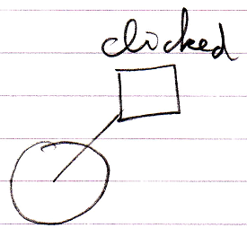 | 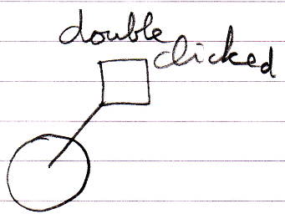
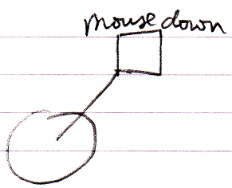 | 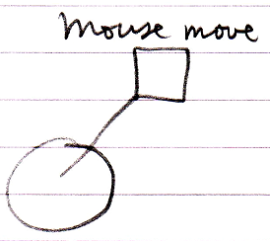 | 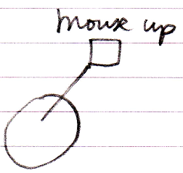
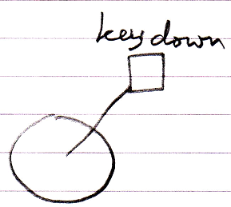 | 